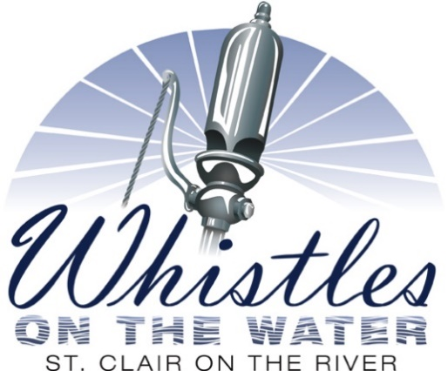
September 25, 2021
9:00 am to 4:00 pm
Palmer Park in Downtown St. Clair
On the banks of the St. Clair River and the United States/Canada Border

Whistles on the Water recreates the time when steamships were the “Royalty” of the Great Lakes. During the 19th century steamships were identified by the uniqueness of their steam whistle. Ship captains would tune their steam whistle to create a unique sound so that their ship could be identified before it could be seen. While this custom seems quaint to us today, it was helpful to the captains of the Great Lakes in identifying a nearby ship in poor visibility before radios were employed on ships.

When the Great Lakes shipping switched from steam to diesel engines, this unique characteristic of the Lakes disappeared.

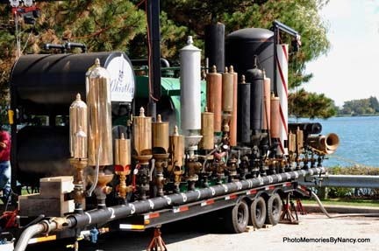
Whistles on the Water uses a massive steam boiler that produces 250 pounds per square inch of pressure. The boiler produces an authentic sound common during the 19th century when steamships ruled the Great Lakes. This is the only steam whistle event in North America that these massive whistles from 19th century can be heard.

If you are a steam whistle owner and would like to bring your whistle to our event, please complete this form: attached is the form to be completed and linked to this page.

Due to the pandemic, there will be NO bleachers installed at this year’s event.
You will need to bring your own chair(s).

