CITY OF ST. CLIAR
ZONING BOARD OF APPEALS SPECIAL MEETING
WEDNESDAY, OCTOBER 19, 2022
ST. CLAIR CITY HALL
547 N. CARNEY, ST. CLAIR

CALL TO ORDER: Chairman Jim Bier – 7:05 p.m.

ROLL CALL: Chairman: Jim Bier Vice Chair: Doug Glassford
Secretary: Joann Westrick Member: Doug Vernier
Member: Ralph Gizowski Member: Diane Ives
Member: Burton Brooks

ABSENT: Joann Westrick – excused absence

AUDIENCE: Thomas Lutkenhoff, Jessica Laparl

APPROVAL OF AGENDA: Doug Vernier made a motion to approve the agenda as presented for October 19, 2022, supported by Diane Ives. All in favor, none opposed.

APPROVAL OF MINUTES: Burton Brooks made a motion to approve the minutes as presented for September 21, 2022, supported by Doug Glassford. All in favor, none opposed

CORRESPONDENCE: None

UNFINISHED BUSINESS: None

Jim Bier – Before we open the public hearing could we get Dee to give a quick review?

Dee Boulier – The applicant is asking for a variance request for their fence. We have multiple fences on the neighboring side yards, actually all of three sides. The contractor had put the structural posts to the outside of the yard which isn’t per code. It wouldn’t be hard to switch them but it could be costly.

The ordinance calls for the structural posts to be on the inside of the property. This particular fence, if you look at some of the pictures, it does have a batten strip to the inside which should be on the outside.

Jim Bier – In other words, the posts should be visible to the property owner’s side.

Dee Boulier – Correct, the 4x4 posts should be inside. It is a 2x6 horizontal fence and what they do is to anchor them to the 4x4 posts and then put a batten strip on the opposite side giving a 2x6 facing outside.

Jim Bier – Thank you Dee and with that I would entertain a motion to open the public hearing.

Doug Glassford made a motion to open the public hearing, supported by Diane Ives. All in favor none opposed.

PUBLIC HEARING: Michael & Jessica LaParl
932 Thornapple Street
74-07-280-0005-000
Section 5.5.1(A) – Walls & Screens in a Residential District

Jim Bier – Would the petitioner please approach the microphone and state you name and address.

Jessica LaParl – 932 Thornapple Street. My husband and I installed a privacy fence. There was an existing fence on all three sides. On one side we had a chain link fence removed in order to place the privacy fence and on the back side there was a wooden fence that we had removed. We removed those two and replaced them with the privacy fence but as Dee stated there were existing fences on all three sides so the contractor was not able to put the posts on the inside.

We had spoken to the neighbors about this initially. I know the one neighbor to the right; we had spoken to her about a week before the contractor came out and she had wanted her fence removed. We were out of town when the contractor was there doing the install, he removed her chain link fence and then she wanted it re-installed because she decided she didn’t want it removed. At our cost, we had the contractor re-install her fence when he put up our privacy fence. If we need to flip any of the sides, we are not sure how to do that.

Jim Bier – We have correspondence tonight from Jill Stockwell, is she on the other side?

Jessica LaParl – She is on the other side. I believe she is the landlord of the house to the other side.

Jim Bier – Are you familiar with what her concerns are?

Jessica LaParl – I am not entirely, initially her concern was that we took out the chain link fence on that side.

Jim Bier read the email which was received from Jill Stockwell and embedded in the minutes.

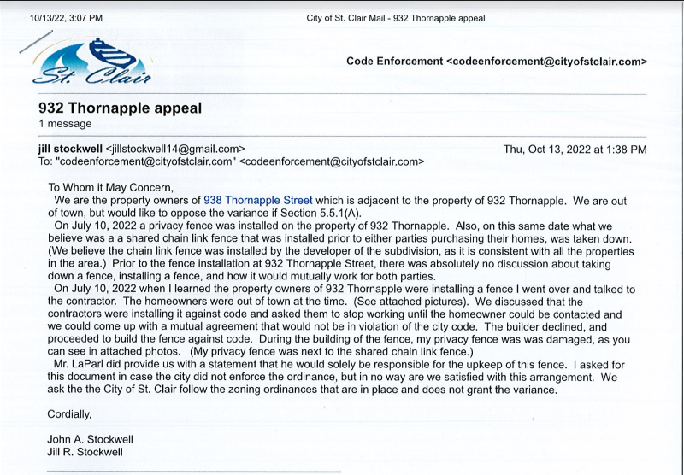

Jim Bier – She states another set of facts are those understood by you?

Jessica LaParl – We had a conversation with her and we have a bunch of images and pictures prior to taking down the chain link fence between our houses. From what we understand, the posts from that fence were on our side so it was our chain link fence. She has a privacy fence on her side so I am not sure if it would be to code for her to install a wood privacy fence when she already had a chain link fence. That really doesn’t make sense to me. Did she want us to put up a wood privacy fence and keep the chain link and her wood privacy fence? We would have had a total of three fence structures between our properties. That didn’t really make sense to us at that point. Once we should her the pictures of the chain link fence, she never contacted us again and she said it made sense that it was our fence to take down. She seemed ok with it at that time and that is when we came up with the letter and we agreed on the letter so we weren’t aware that she had a problem with the fence. She didn’t make it known to us.

Ralph Gizowski – The neighbors’ fence and your chain link fence are next to one another. Was her privacy fence connected to the cyclone fence at that time?

Jessica LaParl – No, I don’t believe so.

Tom Lutkenhoff – Code Enforcement Officer, City of St Clair. When I arrived, I took pictures of the existing fence that I saw, When I got there the full project was done so I don’t know if the Stockwell’s fence was damaged before or during the construction of the new fence.

Ralph Gizowski – When I look at the pictures, I see aging of the fence where some of it looked rotted. Within her letter and pictures, I don’t agree with what she is saying. Seems like they were good neighbors and now they are disagreeing with the fence.

If you didn’t see the old fence prior to the contractor putting up the new fence we don’t know if it was broken prior or during the construction so we shouldn’t even be looking at the neighbor’s fence.

Diane Ives – Is the neighbor who wrote the letter opposing the fence entirely? Does she want to see a different side or does she just want her fence fixed?

Dee Boulier – In reading the letter, I am assuming she wants the fence put in according to ordinance which would put the structural posts to the inside. They had two fences to contend with in order to do that.

Ralph Gizowski – So LaParl’s put their fence on their own property. What is the complaint of the neighbors? Is it the way the fence is built?

Jim Bier – Jessica can you come back up please? On the adjacent property one of the rear fences blocking the school view, which has been there a long time, is also wrong. It has the smooth side facing the school. Did you and your builder discuss that?

Jessica LaParl – There was existing fencing on all three side properties.

Doug Glassford – You can’t really say we want this fence built when other properties are they same way. You couldn’t have built it any other way when there are existing fences in the way.

Jim Bier – Although it isn’t really pertinent to what we are discussing other than recognizing that the rear yard abutting Eddy, across all of those properties, has a variety of fencing conditions. Most likely at some point the school installed the chain link fence but for what ever reason the neighbors wanted privacy fences across their rear property line they put the fences up on their side with a variety of builds. Most likely at that time no permits were required.

Doug Glassford made a motion to close the public hearing, supported by Doug Vernier. All in favor, none opposed.

NEW BUSINESS: Michael & Jessica LaParl
932 Thornapple Street
74-07-280-0005-000
Section 5.5.1(A) – Walls & Screens in a Residential District

Doug Vernier – Was a permit pulled prior to the construction of the fence?

Dee Boulier – No, they have a permit now, but Tom had already had communication with them telling them that it was wrong.

Jim Bier – So this is a dilemma, we have a variety of circumstances. We now understand that the fence was installed without a permit so they didn’t have benefit of input from the city.

Doug Vernier – Is there a fine if they don’t have a permit?

Dee Boulier – We could charge them double for working without a permit but they came right out when they were informed they needed one.

Diane Ives – Is there a problem with removing the chain link fence? Is that part of the issue?

Tom Lutkenhoff – I think the request for variance is that they want to keep the fence the way it is. Whether the chain link fence should be there or not is separate from what the variance request is.

Dee Boulier – The only difference you will see on the fence would be two inches of difference and the structural posts going into the ground. Appearance is the same on either side, one side just has more depth.

Jim Bier – Jessica what is your opinion of the damage they say took place to the neighbors’ fence?

Jessica LaParl – I can’t say for 100% other than there was a reason that we put our own fence in. We wanted to improve the looks to our back yard.

Jim Bier – Jill Stockwell makes a reference to an agreement that your husband gave her. Can you explain that?

Jessica LaParl – Jill was concerned that with the post being on her side that she would be liable for the upkeep and maintenance of the fence. The letter basically states that we will be maintaining that fence. My husband and I both signed it and she was in agreeance with it and we hadn’t heard any different.

Diane Ives – Is this new fence on your property or on the lot line?

Jessica LaParl – To my knowledge it is on our property. The contractor had to come in a little into our yard as he was setting the posts.

Diane Ives – Do you know why the Mays’ wanted the chain link to go back up?

Jessica LaParl – No, she may have had a change of heart. She had our contractor give her a quote for a fence replacement.

Jim Bier – Unless anyone else has further discussion we will move to fact finding.

Finding of Fact:

Ralph Gizowski – I say leave it alone. The backside fence to the school should be grandfathered in with the rest of the houses that are there. The letter that we received from the Stockwell’s I cannot view it in their favor. The fence that they are talking about that was damaged is 15/20 years old, it is a rental property and we can’t determine if it was damaged during the construction of the LaParl’s fence. As was mentioned in our conversations that the Stockwell’s stockade fence is taller than the LaParl’s fence. I don’t see what the issue is and I don’t think the LaParl’s need to change what they did. They neglected to pull a permit but they did once they found out they needed one.

Burton Brooks – Looking at the pictures and seeing the variety of the other fences that are probably not meeting the code either I am inclined to leave it be.

Diane Ives – I am inclined to say the same. Leave it. If anyone were to object would be the Mays and they are not objecting to it.

Doug Vernier – Under normal circumstances if somebody didn’t get a permit and reversed the fence, I would probably say they would have to make it right. With all of the conditions of the other fences, this case is unusual and I would say leave it.

Doug Glassford – I am going to say the same thing. There are so many other grandfathered in situations this matches up to what is going on the neighborhood. With the stockade fence being above LaParl’s fence line, I am going to say leave it.

Jim Bier – I concur with everything that has been said and will state along with what Doug Vernier said; the failure to pull a permit to get the input from the city to get the proper method of installation really qualifies as a self-created hardship which would typically not be grounds for granting a variance but when you look at the context of the other circumstances it becomes to me unreasonably punitive to make them go and change something that provides no true benefit to any of the parties. My feeling is the variance is acceptable.

With that being said I would entertain a motion to accept this variance.

Doug Glassford made a motion to vote on the variance requested on property #74-07-280-0005-000 of Section 5.5.1(a) to allow the installation for privacy as it stands now. Supported by Doug Vernier.
Roll Call
Jim Bier – Yes
Doug Glassford – Yes
Doug Vernier – Yes
Ralph Gizowski – Yes
Diane Ives – Yes
Burton Brooks – Yes

Jim Bier – Motion carries. Thank you for your patience, Jessica.

Doug Glassford made a motion to adjourn, supported by Burton Brooks. All in favor, none opposed.

Meeting adjourned at 7:40 p.m.

