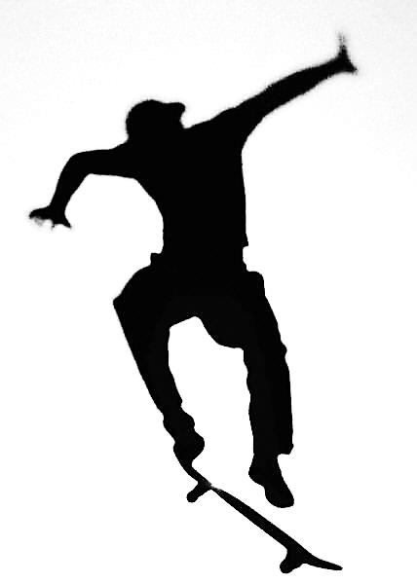
2015 SUMMER JAM – SKATE & BIKE EVENT

WAIVER AND WARNING!
Skateboarding/biking can be risky. When skateboarders lose their balance they can fall, sometimes hard. This may cause an injury. Another skater or their skateboard can also possibly strike you.

I understand that a helmet and elbow and knee pads (with plastic caps) may reduce my risk of injury while skateboarding, inline skating or biking on the property of the City of St. Clair . I agree to obey all the competition rules and regulations and understand that I could be disqualified or eliminated from competition(s) if I do not follow these rules.

I have read and understood this warning and waiver. I understand that the City of St. Clair Recreation Department sponsor of the events, along with its cosponsor, assumes no responsibility for any injury that might be suffered by the participant (or my child if signing on behalf of my child) and that the participant assumes all risk for personal injury or loss or damage of property or loss or damage of property. Please Print Clearly

Name

Birth Date | / / / |  | Age:
Address

City

State

Zip code

Email:

Emergency Phone #

Emergency Contact

Signature of Participant or Parent of Participant (if Under age 18)
PLEASE PRINTNAME:
ENTRY FEE ______________________

