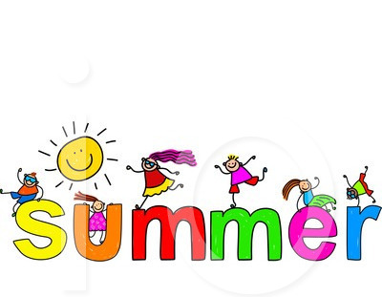
City of St. Clair Recreation Department

New Instructor: Stephanie Hilton
Introduction to ballet and jazz. Soft soled, non-marking shoes. Dance shoe not required for summer program. Wednesdays, June 23 – July 23 (5wks). $45.00, $35.00 Resident Discount
Ballet (4-5yrs) 4:00pm-4:45pm Jazz (6-8yrs)* 4:45pm-5:30pm Jazz (9 & up)* 5:30pm-6:15pm

*Please note Jazz classes may be combined due to minimum registration required for class.
Have a fun Summer, see you in the Fall!!
Registration on-going City of St. Clair Recreation Department 547 N. Carney Drive, St. Clair, MI 48079 810.329.7121 www.cityofstclair.com

